(4 marks, file to be edited: Q2.cpp)
Notes: (1) Your task is to complete 2 functions: fen() and fun(). (2) You can create other function(s), if you see it is necessary. (3) Do not edit the main function. (3) Suppose that a user enter data correctly, thus you do not need to write code to check input.

TC1:
Complete the given fen(double x, double y, int n) function, which calculates and returns the value fen(x,y,n) using the formula below:

fen(x,y,n) = (1+ 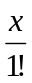 + 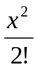 + ... +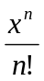) + (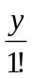- 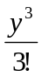 + 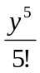 -... +(-1)^{n} 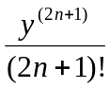)

TC2:
Complete the function fun(int a[], int &n). The task of the function fun:
Check if n is odd (e.g. n = 7) then sort the array ascendingly.
otherwise (i.e. n is even) delete the first maximum value in the array.

Sample input and output:
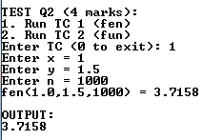 | 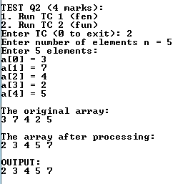 | 